# **ECOR 1010 – Introduction to Engineering**

**reverse engineering project**

**Mechanical Watch: Mainspring Modification**

***To:***

Steven Sonnenberg [StevenSonnenberg@cmail.carleton.ca](mailto:StevenSonnenberg@cmail.carleton.ca)

Mark Kotwicz [MarkKotwiczHerniczek@cmail.carleton.ca](mailto:MarkKotwiczHerniczek@cmail.carleton.ca)

***From:***

|  |  |  |
| --- | --- | --- |
| Fareen Lavji | 101036543 | [FareenLavji@cmail.carleton.ca](mailto:FareenLavji@cmail.carleton.ca) |
| Tooba Sheikh | 101028915 | [ToobaSheikh@cmail.carleton.ca](mailto:ToobaSheikh@cmail.carleton.ca) |
| Fatima Hashi | 101041794 | [FatimaHashi@cmail.carleton.ca](mailto:FatimaHashi@cmail.carleton.ca) |

**Lab Section: L7**

**Project Group Number: L7-20**

**Date: Dec 2, 2016**

**CARLETON UNIVERSITY**

# Table of contents

Abstract 3

Introduction 4

Method 4

Results 4

Manufacturing Material 4

Manufacturing Process 4

Discussion 5

Failure Mode 5

Benefits of Redesign 5

Conclusion 5

Appendix

IntelliCAD Drawing 6

3D Rendered Model 7

# abstract

A mechanical watch depends on mechanical energy to function properly. This energy is stored in a mainspring that is enclosed within a barrel containing another component, named the arbour. The mainspring is attached to the arbour, and inner part of the barrel and must be wound up frequently in order to work. The goal of this project was to extend the lifeline of the mainspring by creating a locking mechanism that could notify the user that the watch is wound up enough. After various proposed theories, a simple ball and hole mechanism was selected. This mechanism calls for a hole in the mainspring, made at an optimal point, calculated by measuring the circumference coiled by a watch’s recommended turns [1]. The hole encases a metal ball that can freely move about the chamber until it descends into a groove introduced onto the base of the chamber. This mechanism allowed the spring to lock, thereby achieving the desired results. The detailed benefits of this redesign are further discussed along with a description of the procedure required to produce this product.

# Introduction

The mainspring of a mechanical watch is the primary component of the instrument that helps users tell the time and is the only component that needs to be wound up by hand. It has become a widespread cause of complaint for users to replace their mainsprings due to metal fatigue caused by excessive stress from winding the mainspring. It was for this purpose, that the team took it upon themselves to extend the longevity of the mainspring, to increase sustainability on a micro scale.

# Method

For most watches, the mainspring should be wound to have the barrel turn 6.5 times. But a sample mainspring (Marvin 13 Ligne wristwatch carbon steel spring) was used which requires a total of 6.6 turns. 6.6 turns call for 313.50 mm of the 320.00mm length to be unfurled. [1] Winding past this point can stretch the coil thereby causing fatigue in the material. So, in order to indicate that the watch has reached its optimal wind, a hole has been introduced at this point, where the center corresponds to the winding length. The hole then has a small metal ball that can roll across the base of the barrel holding the mainspring. A ball was used to reduce friction and provide for smooth travel of the mechanism. Also, a sphere is the strongest 3-D shape at all points of the sphere.

There are however some design constraints, being such a small part with such a minor modification, precision is key for the manufacturing. However, micro watches far smaller than the sample have been manufactured [2] so this should not pose as a giant obstacle. The software used to simulate this modification was PTC Creo Parametric and AutoCAD.

# Results

In order for the mechanism – described above – to work, a gradual depression of 0.05mm max depth must be introduced into the barrel base to catch the ball as soon as it starts travelling. This capture causes the ball to drop halfway and lock with the mainspring, thereby creating resistance that the user can feel. This pressure indicates that the watch has reached its optimal winding point.

**Manufacturing Material:**

The material used to make the mainspring and the ball is a white alloy, composed of nickel, chrome, and cobalt metal. The benefits of manufacturing a white alloy mainspring is its resilience to corrosion, which is important so that the objects do not build up rust. The alloy increases the longevity of the mainspring so that it does not break or lose performance. The white alloy has a higher elastic limit than most metals, such as carbon and steel (which were used as mainspring materials pre-1950’s). The mainspring will not deteriorate whilst maintaining a constant torque. [1]

**Manufacturing Process:**

The manufacturing should follow conventional procedure, in which the alloy is heated so that it maintains flexibility and is shaped into its specific dimensions. It is in the heated stage where the stopper hole is grooved in and the barrel is cut out. At this stage, when the alloy is malleable, the hole should be cut into the spring. Directly after the coiling process, the mainspring is placed into an oven, decreasing the temperature, which allows the metal to slowly cool down and harden. To ensure a smooth, clean finish, the mainspring rotates around an abrasive wheel, flattening the surface. Lastly, it is cooled in water and packaged so that it can be transferred to the watch manufacturing facility. [3]

# Discussion

**Failure Mode:**

One of the drawbacks of having a loose part in the hole is that it could possibly slip out. Although the calculations took that into consideration, rough usage of the watch can force the ball out of the hole leading it to pop out and potentially ruin the timepiece

**Benefits of Redesign:**

The reason this redesign is beneficial is not only to increase longevity of the mainspring, but to also provide a more accurate reading of the clock. As the spring deteriorates, so does the torque, because this force is not constant, the accuracy can also deteriorate over time. It is also important to note, that during servicing, the springs hold a lot of tensional residue which can pose as a hazard; humid weather or sudden knocks and jerks can cause a tightly wound spring to be more susceptible to breakage. All of this can be reduced by the simple mechanism introduced in this proposal.

# Conclusions

The product is recommended to be manufactured with the white alloy mentioned above, but can be manufactured with carbon steel, although the ball would still need to be produced using the alloy. Thus, it can be concluded that redesigning the mainspring, not only increases the lifespan of the spring itself, but can potentially increase the lifespan of the watch and reduce servicing costs associated with owning a mechanical watch.

# References

|  |  |
| --- | --- |
| [1] | D. Boettcher, "Watch Movements 2," 2006 - 2016. [Online]. Available: http://www.vintagewatchstraps.com/watchmovement2.php. |
| [2] | James Edition, "World's Smalles Mechanical Watch Movement Is The Jaegar-LeCoutlre Calibre 101," 16 Jul 2009. [Online]. Available: http://www.jamesedition.com/stories/watches/worlds-smallest-mechanical-watch-movement-is-the-jaeger-lecoultre-calibre-101-209. |
| [3] | Advameg, Inc., "How Products are Made," 2016. [Online]. Available: http://www.madehow.com/Volume-6/Springs.html. |

# intellicad Drawing

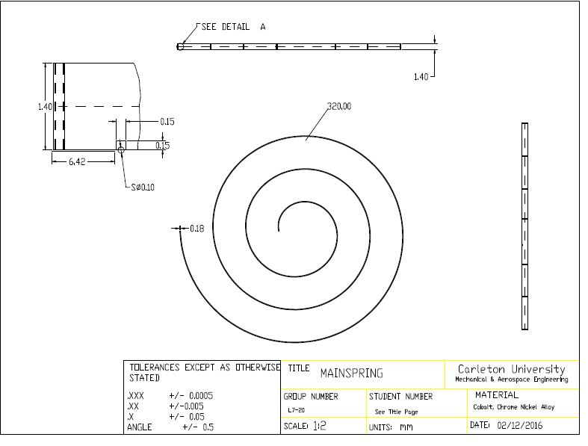

# CREO Pro/E rendered solid model

